

**Usman Institute of Technology**

**Department of Computer Science**

**Course Code: SE312**

**Course Title: Software Construction and Development**

**SPRING 2024**

**Lab 06**

**Objective: To acquire knowledge of the fundamental principles of OOP such as inheritance, polymorphism, abstraction and encapsulation.**

**Student Information**

|  |  |
| --- | --- |
| Student Name | Syed Muhammad Zaid |
| Student ID | 20B-052-SE |
| Date | 4/27/2024 |

**Assessment**

|  |  |
| --- | --- |
| Marks Obtained |  |
| Remarks |  |
| Signature |  |

**LAB TASKS:**

1. Define a BankAccount class with private attributes such as account number, balance, and owner's name. Implement public methods like deposit() and withdraw() to ensure proper encapsulation of account data. Create an AccountHolder class with private attributes for username, password, and email. Implement methods for user authentication and password reset while keeping sensitive data encapsulated.

**BANK ACCOUNT CLASS:**

public class BankAccount {  
 private int account_number;  
 private int account_balance;  
 private String owners_name;  
  
 public BankAccount(int account_balance,int account_number,String owners_name){  
 this.account_balance = account_balance;  
 this.account_number = account_number;  
 this.owners_name = owners_name;  
 }  
 public void deposit(int amount){  
 this.account_balance += amount;  
 System.*out*.println("The amount "+amount+" is deposited into the account:\n"+this.account_number+"\n"+this.owners_name);  
 }  
 public void checkBalance(){  
 System.*out*.println(this.owners_name+" with account number: "+this.account_number+" has current balance of: "+this.account_balance);  
 }  
 public void withdraw(int amount){  
 this.account_balance = this.account_balance - amount;  
 System.*out*.println("The amount "+amount+" is withdrawn from the account:\n"+this.account_number+"\n"+this.owners_name);  
 }  
}

**ACCOUNT HOLDER CLASS:**

import java.util.Scanner;  
public class AccountHolder {  
 private String username;  
 private String password;  
 private String email;  
  
 public AccountHolder(String username, String password, String email) {  
 this.username = username;  
 this.password = password;  
 this.email = email;  
  
 }  
  
 public void Authentication(int retry_count){  
 Scanner scanner = new Scanner(System.*in*);  
 System.*out*.println("Enter your password: ");  
 String input_password = scanner.nextLine();  
 if (retry_count > 2){  
 System.*out*.println("Out of tries, try again later!");  
 return;  
 }  
 else if (input_password.equals(this.password) && retry_count < 2){  
 System.*out*.println("The user has logged in successfully.");  
  
 }  
 else {  
 System.*out*.println("Wrong password!" + retry_count);  
 retry_count ++;  
 Authentication(retry_count);  
 }  
  
 }  
  
}

**OUTPUT:**

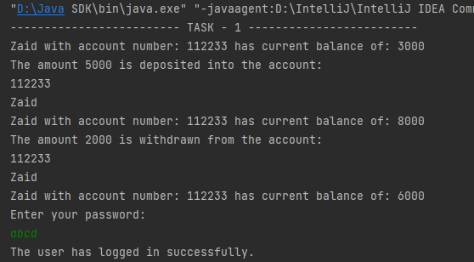

1. Write a Java program to create a class called "Employee" with a name, job title, and salary attributes, and methods to calculate and update salary.

public class Employee {  
 public String employee_name;  
 public String job_title;  
 private double salary;  
  
 public Employee(String employee_name, String job_title, double salary) {  
 this.employee_name = employee_name;  
 this.job_title = job_title;  
 this.salary = salary;  
 }  
  
 public double getSalary(){  
 return this.salary;  
 }  
 public void setSalary(double new_amount){  
 double prev_salary = this.salary;  
 this.salary = new_amount;  
 System.*out*.println("Previous Salary was: "+prev_salary+" now updated to: "+this.salary);  
 }  
}

**OUTPUT:**



1. Write a Java program to create a class called "Movie" with attributes for title, director, actors, and reviews, and methods for adding and retrieving reviews.

public class Movie {  
 private String title;  
 private String director;  
 private String[] actors;  
 private String[] reviews;  
 private int reviewCount;  
  
 public Movie(String title, String director, String[] actors) {  
 this.title = title;  
 this.director = director;  
 this.actors = actors;  
 this.reviews = new String[10];  
 this.reviewCount = 0;  
 }  
  
 public void addReview(String review) {  
 if (reviewCount < 10) {  
 reviews[reviewCount] = review;  
 reviewCount++;  
 } else {  
 System.*out*.println("Maximum reviews limit reached!");  
 }  
 }  
  
 public String[] getReviews() {  
 return reviews;  
 }  
}

**OUTPUT:**

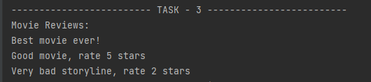

**HOME TASK:**

1. Write a Java program to create class called “TrafficLight” with attributes for color and duration, and methods to change the color and check for red or green.
2. /*  
   * Write a Java program to create class called “TrafficLight” with attributes for color and duration,  
   * and methods to change the color and check for red or green.  
   * */  
   public class TrafficLights {  
    public String color;  
    public int duration;  
     
    public TrafficLights(String color,int duration){  
    this.color = color;  
    this.duration = duration;  
    }  
     
    public void changeColor(){  
    if (this.color == "Red"){  
    System.*out*.println("Changed color to Yellow");  
    }  
    if (this.color == "Yellow"){  
    System.*out*.println("Changed color to Green");  
    }  
    if (this.color == "Green"){  
    System.*out*.println("Changed color to Red");  
    }  
    }  
     
    public void currentStatus(){  
    System.*out*.println("The current light blinking is of color: "+this.color+" will be changing in: "+this.duration);  
    }  
     
   }

**OUTPUT:**

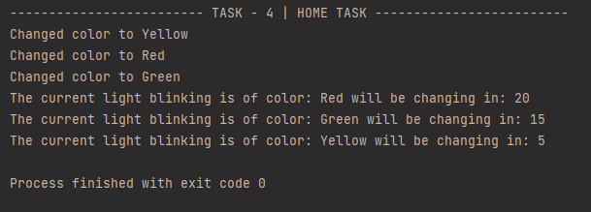

**MAIN.JAVA CODE (for running tasks):**

public class Main {  
 public static void main(String[] args) {  
 System.*out*.println("------------------------- TASK - 1 -------------------------");  
 BankAccount bankAccount1 = new BankAccount(3000, 112233, "Zaid");  
 bankAccount1.checkBalance();  
 bankAccount1.deposit(5000);  
 bankAccount1.checkBalance();  
 bankAccount1.withdraw(2000);  
 bankAccount1.checkBalance();  
  
 AccountHolder accountHolder1 = new AccountHolder("zaid","abcd","zaid@gmail.com");  
 accountHolder1.Authentication(0);  
  
 System.*out*.println("------------------------- TASK - 2 -------------------------");  
 Employee employee1 = new Employee("Zaid", "Manager", 100000);  
 employee1.getSalary();  
 employee1.setSalary(120000);  
  
 System.*out*.println("------------------------- TASK - 3 -------------------------");  
 Movie movie1 = new Movie("Avengers", "Tom", new String[]{"Tony", "Tina"});  
 movie1.addReview("Best movie ever!");  
 movie1.addReview("Good movie, rate 5 stars");  
 movie1.addReview("Very bad storyline, rate 2 stars");  
 System.*out*.println("Movie Reviews:");  
 for (String review: movie1.getReviews()) {  
 if (review != null) {  
 System.*out*.println(review);  
 }  
 }  
  
 System.*out*.println("------------------------- TASK - 4 | HOME TASK -------------------------");  
 TrafficLights trafficLights1 = new TrafficLights("Red",20);  
 TrafficLights trafficLights2 = new TrafficLights("Green",15);  
 TrafficLights trafficLights3 = new TrafficLights("Yellow",5);  
  
 trafficLights1.changeColor();  
 trafficLights2.changeColor();  
 trafficLights3.changeColor();  
  
 trafficLights1.currentStatus();  
 trafficLights2.currentStatus();  
 trafficLights3.currentStatus();  
 }  
}